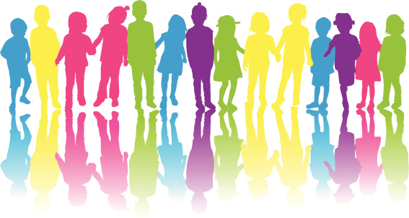Howard House Safeguarding Policy

(Child Friendly Version)

*What is this?*

Howard House has a Safeguarding Policy for staff and other professionals. This ‘child friendly’ policy is designed for young people and this should be read as a guide to the main policy.

*What is it for?*

To help you decide what could be a ‘problem’ and where to go to get help and support.

*Is someone bullying you?*

You must tell someone at Howard House or in your school so that we can help you.

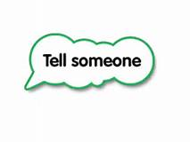Examples of people you can tell are:

* Your keyworker
* Staff on duty
* Management
* Teachers at school
* Your head teacher

Have a look at your ‘Child Friendly Anti-Bullying Policy’.

*Saying funny things to you?*

Has someone said something to you or have you heard something that you do not like or upsets you?

You must tell someone at Howard House or in your school so that we can help you.

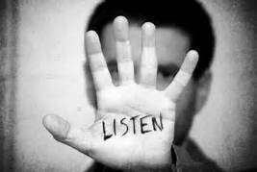Examples of people you can tell are:

* Your keyworker
* Staff on duty
* Management
* Teachers at school
* Your head teacher

An adult WILL listen!

*Touching you*

Has someone made you feel uncomfortable about how or where they have touched you? Or spoke about touching you in a way that would make you feel worried or uncomfortable?

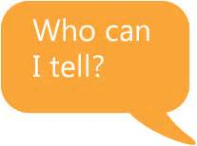You must tell someone at Howard House or in your school so that we can help you.

Examples of people you can tell are:

* Your keyworker
* Staff on duty
* Management
* Teachers at school/ Your head teacher

*Hitting, punching or smacking you*

Has someone hit, punched or smacked you or hurt you in any way?

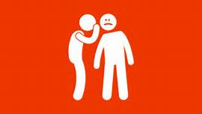You must tell someone at Howard House or in your school so that we can help you.

Examples of people you can tell are:

* Your keyworker
* Staff on duty
* Management
* Teachers at school
* Your head teacher

If in doubt, talk to someone. There are many staff at Howard House for you to talk you and they will help support you and listen!

*E-Safety*

Has anyone sent you unkind messages or threatened you on social media?

Have you seen anything that has upset or worried you online?

Has someone off the internet asked you to do anything that made you feel uncomfortable?

You must tell someone at Howard House or in your school so that we can help you.

Examples of people you can tell are:

* Your keyworker
* Staff on duty
* Management
* Teachers at school
* Your head teacher

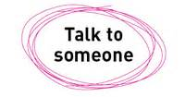Always remember BUDDY

Being kind

Understanding other people’s feelings

Doing the best you can

Don’t keep sad feelings to yourself

You have the right to be safe and happy

*What is Sexual Exploitation?*

“Someone talking advantage of you sexually, for their own benefit. Through threats, bribes, violence, humiliation, or by telling you that they love you, they will have the power to get you to do sexual things for their own, or other people’s benefit or enjoyment (including touching or kissing private parts, sex, taking sexual photos.)” (NWG-Network, 2008)

*Could this be you or a friend?*

|  |  |
| --- | --- |
| Do you stay out overnight? | If this sounds like your life, or you are worried about a friend, you or your friend could be at risk of child sexual exploitation by older adults. Taking risks is part of growing up, but sometimes young people get out of their depth and need some help.  Services in Northumberland are ready to help if something is happening to you – say something.   * Tell an adult * Tell a friend you know will tell a teacher or other useful adult * Ring 101 and report it to the police. * Ring REACH (Sexual Assault) 0191 221 9222 * CEOP (Child Exploitation & Online Protection) 0370 496 7622 * ChildLine 0800 1111 |
| Have you been missing from home? |
| Do you miss school? |
| Does a grown-up outside your family give you money, clothes, jewellery, a mobile phone, alcohol or other presents? |
| Do you have an older boyfriend or girlfriend? |
| Do you take drugs or drink alcohol? |
| Are you losing touch with your family or friends? |
| Do you hate yourself sometimes? |
| Are you secretive about where you go and who you see? |
| Do you chat to people online you have never met? |

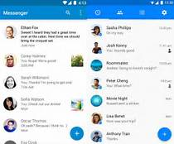

**

*So how does child sexual exploitation (CSE) happen?*

We know from experience that some adults draw young people just like you into sexual relationships. They are not really your friends.

This is how it works:

* Older adults are nice to you
* They show you a lot of interest and affection at the beginning, make you feel special
* Sometimes they ask groups of young people to come back to their house with older adults
* They offer you drugs and alcohol and a place to chill out
* They may even buy you presents like clothes, a mobile phone, even give you money to buy things like cigarettes
* When they have gained your trust and affection they may change how they act around you
* They will ask for sex or sexual touching for themselves or other people, in return for alcohol, drugs, presents, money; all the things they gave you for free a while ago
* They stop being nice and become threatening and violent

*What can I do?*

YOU ARE NOT TO BLAME IF THIS IS HAPPENING TO YOU.

The adults who have taken advantage of you are responsible and they are the people who have done something wrong.

They might have told you it is your fault and you will get into trouble but that is just a lie to frighten you.

If you are worried about yourself or another young person you should talk to an adult straight away.

Refer back to the table on page 4 for telephone numbers.

*WE HAVE PROVIDED YOU WITH LOTS OF WEBSITES AND WAYS TO GET HELP BELOW THAT YOU MAY FIND USEFUL.*

*RESOURCES FOR YOUNG PEOPLE*

|  |
| --- |
| *Childline*  <http://www.childline.org.uk/Play/GetInvolved/Pages/sexting-zipit-app.aspx>  This app provides witty comebacks for young people to use when they are being pressured to take pics or flirting becomes sexting. Helps young people save face and gives them confidence to deal with potential perpetrators. |
| *Face up to it*  [www.faceup2it.org](http://www.faceup2it.org)  This is an interactive web site aimed at 13+. It has boy and girl stories that allow the young person to make choices and see outcomes. There is also a mock up chat room which shows you how you cannot always believe who you are talking to is who they say they are. |
| *‘Wud U?’ Barnardo’s free app for young people*  The app is available to download from the Windows Store, The Apple Store and Google Play. Interactive app that has 3 x boys and 3 x girls stories that help young people understand grooming and CSE. |
| *Barnardo’s – Sexual Exploitation: Sex, Secrets and Lies*  This is a guide which examines the risks young people face and explores ways of keeping safe. It is FREE to download from [www.barnardos.org.uk](http://www.barnardos.org.uk) along with other good resources. |
| *CEOP – Child Exploitation Online Protection (parents, professionals and young people)*  http://ceop.police.uk |
| *ThinkUKnow*  [www.ThinkUKnow.co.uk](http://www.ThinkUKnow.co.uk)  Website with pages for young people in different age groups. DVD clips for young people that show the dangers of social media, give an understanding of grooming and CSE and tips to keep safe. |
| *It’s not Okay*  A website developed by Project Pheonix, a group of agencies who want to help children and young people who could be hurt by CSE.  [www.itsnotokay.co.uk](http://www.itsnotokay.co.uk) |

If you feel unsafe in any way about anything in this policy… TELL SOMEONE. Staff at Howard House are ALWAYS here to listen.